






Plan and manage menu-based catering
D1.HCC.CL2.06
Trainer Guide

Plan and manage menu-based catering

D1.HCC.CL2.06

Trainer Guide




Project Base
William Angliss Institute of TAFE
555 La Trobe Street
Melbourne 3000 Victoria
Telephone: | (03) 9606 2111
Facsimile: | (03) 9670 1330
Acknowledgements
Project Director: | Wayne Crosbie
Chief Writer: | Alan Hickman
Subject Writer: | Garry Blackburn
Project Manager: | Alan Maguire
Editor: | Jim Irwin
DTP/Production: | Daniel Chee, Mai Vu, Kaly Quach

The Association of Southeast Asian Nations (ASEAN) was established on 8 August 1967. The Member States of the Association are Brunei Darussalam, Cambodia, Indonesia, Lao PDR, Malaysia, Myanmar, Philippines, Singapore, Thailand and Viet Nam.
The ASEAN Secretariat is based in Jakarta, Indonesia.
General Information on ASEAN appears online at the ASEAN Website: www.asean.org.
All text is produced by William Angliss Institute of TAFE for the ASEAN Project on “Toolbox Development for Front Office, Food and Beverage Services and Food Production Divisions”.
This publication is supported by the Australian Government’s aid program through the ASEAN-Australia Development Cooperation Program Phase II (AADCP II).
Copyright: Association of Southeast Asian Nations (ASEAN) 2013.
All rights reserved.
Disclaimer
Every effort has been made to ensure that this publication is free from errors or omissions. However, you should conduct your own enquiries and seek professional advice before relying on any fact, statement or matter contained in this book. The ASEAN Secretariat and William Angliss Institute of TAFE are not responsible for any injury, loss or damage as a result of material included or omitted from this course. Information in this module is current at the time of publication. Time of publication is indicated in the date stamp at the bottom of each page.
Some images appearing in this resource have been purchased from stock photography suppliers Shutterstock and iStockphoto and other third party copyright owners and as such are non-transferable and non-exclusive. Clip arts, font images and illustrations used are from the Microsoft Office Clip Art and Media Library. Some images have been provided by and are the property of William Angliss Institute.
Additional images have been sourced from Flickr and SKC and are used under Creative Commons licence: http://creativecommons.org/licenses/by/2.0/deed.en
File name: TG_Plan_&_manage_menu-base_catering_FN_030114





Table of Contents
Competency Based Training (CBT) and assessment - An introduction for trainers 1
Competency standard 11
Notes and PowerPoint slides 19
Recommended training equipment 45
Instructions for Trainers for using PowerPoint – Presenter View 47
Appendix – ASEAN acronyms 49

Competency Based Training (CBT) and assessment - An introduction for trainers

Competency
Competency refers to the ability to perform particular tasks and duties to the standard of performance expected in the workplace.
Competency requires the application of specified knowledge, skills and attitudes relevant to effective participation, consistently over time and in the workplace environment.
The essential skills and knowledge are either identified separately or combined.
Knowledge identifies what a person needs to know to perform the work in an informed and effective manner.
Skills describe the application of knowledge to situations where understanding is converted into a workplace outcome.
Attitude describes the founding reasons behind the need for certain knowledge or why skills are performed in a specified manner.
Competency covers all aspects of workplace performance and involves:
- Performing individual tasks
- Managing a range of different tasks
- Responding to contingencies or breakdowns
- Dealing with the responsibilities of the workplace
- Working with others.

Unit of Competency
Like with any training qualification or program, a range of subject topics are identified that focus on the ability in a certain work area, responsibility or function.
Each manual focuses on a specific unit of competency that applies in the hospitality workplace.
In this manual a unit of competency is identified as a ‘unit’.
Each unit of competency identifies a discrete workplace requirement and includes:
- Knowledge and skills that underpin competency
- Language, literacy and numeracy
- Occupational health and safety requirements.
Each unit of competency must be adhered to in training and assessment to ensure consistency of outcomes.

Element of Competency
An element of competency describes the essential outcomes within a unit of competency.
The elements of competency are the basic building blocks of the unit of competency. They describe in terms of outcomes the significant functions and tasks that make up the competency.
In this manual elements of competency are identified as an ‘element’.

Performance criteria
Performance criteria indicate the standard of performance that is required to demonstrate achievement within an element of competency. The standards reflect identified industry skill needs.
Performance criteria will be made up of certain specified skills, knowledge and attitudes.

Learning
For the purpose of this manual learning incorporates two key activities:
- Training
- Assessment.
Both of these activities will be discussed in detail in this introduction.
Today training and assessment can be delivered in a variety of ways. It may be provided to participants:
- On-the-job – in the workplace
- Off-the-job – at an educational institution or dedicated training environment
- As a combination of these two options.
No longer is it necessary for learners to be absent from the workplace for long periods of time in order to obtain recognised and accredited qualifications.

Learning Approaches
This manual will identify two avenues to facilitate learning:
Competency Based Training (CBT)
This is the strategy of developing a participant’s competency.
Educational institutions utilise a range of training strategies to ensure that participants are able to gain the knowledge and skills required for successful:
- Completion of the training program or qualification
- Implementation in the workplace.
The strategies selected should be chosen based on suitability and the learning styles of participants.

Competency Based Assessment (CBA)
This is the strategy of assessing competency of a participant.
Educational institutions utilise a range of assessment strategies to ensure that participants are assessed in a manner that demonstrates validity, fairness, reliability, flexibility and fairness of assessment processes.

Flexibility in Learning
It is important to note that flexibility in training and assessment strategies is required to meet the needs of participants who may have learning difficulties. The strategies used will vary, taking into account the needs of individual participants with learning difficulties. However they will be applied in a manner which does not discriminate against the participant or the participant body as a whole.
Catering for Participant Diversity
Participants have diverse backgrounds, needs and interests. When planning training and assessment activities to cater for individual differences, trainers and assessors should:
- Consider individuals’ experiences, learning styles and interests
- Develop questions and activities that are aimed at different levels of ability
- Modify the expectations for some participants
- Provide opportunities for a variety of forms of participation, such as individual, pair and small group activities
- Assess participants based on individual progress and outcomes.
The diversity among participants also provides a good reason for building up a learning community in which participants support each other’s learning.
Participant Centred Learning
This involves taking into account structuring training and assessment that:
- Builds on strengths – Training environments need to demonstrate the many positive features of local participants (such as the attribution of academic success to effort, and the social nature of achievement motivation) and of their trainers (such as a strong emphasis on subject disciplines and moral responsibility). These strengths and uniqueness of local participants and trainers should be acknowledged and treasured
- Acknowledges prior knowledge and experience – The learning activities should be planned with participants’ prior knowledge and experience in mind
- Understands learning objectives – Each learning activity should have clear learning objectives and participants should be informed of them at the outset. Trainers should also be clear about the purpose of assignments and explain their significance to participants
- Teaches for understanding – The pedagogies chosen should aim at enabling participants to act and think flexibly with what they know
- Teaches for independent learning – Generic skills and reflection should be nurtured through learning activities in appropriate contexts of the curriculum. Participants should be encouraged to take responsibility for their own learning
- Enhances motivation – Learning is most effective when participants are motivated. Various strategies should be used to arouse the interest of participants
- Makes effective use of resources – A variety of teaching resources can be employed as tools for learning
- Maximises engagement – In conducting learning activities, it is important for the minds of participants to be actively engaged
- Aligns assessment with learning and teaching – Feedback and assessment should be an integral part of learning and teaching
- Caters for learner diversity – Trainers should be aware that participants have different characteristics and strengths and try to nurture these rather than impose a standard set of expectations.
Active Learning
The goal of nurturing independent learning in participants does not imply that they always have to work in isolation or solely in a classroom. On the contrary, the construction of knowledge in tourism and hospitality studies can often best be carried out in collaboration with others in the field. Sharing experiences, insights and views on issues of common concern, and working together to collect information through conducting investigative studies in the field (active learning) can contribute a lot to their eventual success.
Active learning has an important part to play in fostering a sense of community in the class. First, to operate successfully, a learning community requires an ethos of acceptance and a sense of trust among participants, and between them and their trainers. Trainers can help to foster acceptance and trust through encouragement and personal example, and by allowing participants to take risks as they explore and articulate their views, however immature these may appear to be. Participants also come to realise that their classmates (and their trainers) are partners in learning and solving.
Trainers can also encourage cooperative learning by designing appropriate group learning tasks, which include, for example, collecting background information, conducting small-scale surveys, or producing media presentations on certain issues and themes. Participants need to be reminded that, while they should work towards successful completion of the field tasks, developing positive peer relationships in the process is an important objective of all group work.

Competency Based Training (CBT)
Principle of Competency Based Training
Competency based training is aimed at developing the knowledge, skills and attitudes of participants, through a variety of training tools.
Training Strategies
The aims of this curriculum are to enable participants to:
- Undertake a variety of subject courses that are relevant to industry in the current environment
- Learn current industry skills, information and trends relevant to industry
- Learn through a range of practical and theoretical approaches
- Be able to identify, explore and solve issues in a productive manner
- Be able to become confident, equipped and flexible managers of the future
- Be ‘job ready’ and a valuable employee in the industry upon graduation of any qualification level.
To ensure participants are able to gain the knowledge and skills required to meet competency in each unit of competency in the qualification, a range of training delivery modes are used.
Types of Training
In choosing learning and teaching strategies, trainers should take into account the practical, complex and multi-disciplinary nature of the subject area, as well as their participant’s prior knowledge, learning styles and abilities.
Training outcomes can be attained by utilising one or more delivery methods:
Lecture/Tutorial
This is a common method of training involving transfer of information from the trainer to the participants. It is an effective approach to introduce new concepts or information to the learners and also to build upon the existing knowledge. The listener is expected to reflect on the subject and seek clarifications on the doubts.
Demonstration
Demonstration is a very effective training method that involves a trainer showing a participant how to perform a task or activity. Through a visual demonstration, trainers may also explain reasoning behind certain actions or provide supplementary information to help facilitate understanding.
Group Discussions
Brainstorming in which all the members in a group express their ideas, views and opinions on a given topic. It is a free flow and exchange of knowledge among the participants and the trainer. The discussion is carried out by the group on the basis of their own experience, perceptions and values. This will facilitate acquiring new knowledge. When everybody is expected to participate in the group discussion, even the introverted persons will also get stimulated and try to articulate their feelings.
The ideas that emerge in the discussions should be noted down and presentations are to be made by the groups. Sometimes consensus needs to be arrived at on a given topic. Group discussions are to be held under the moderation of a leader guided by the trainer. Group discussion technique triggers thinking process, encourages interactions and enhances communication skills.
Role Play
This is a common and very effective method of bringing into the classroom real life situations, which may not otherwise be possible. Participants are made to enact a particular role so as to give a real feel of the roles they may be called upon to play. This enables participants to understand the behaviour of others as well as their own emotions and feelings. The instructor must brief the role players on what is expected of them. The role player may either be given a ready-made script, which they can memorise and enact, or they may be required to develop their own scripts around a given situation. This technique is extremely useful in understanding creative selling techniques and human relations. It can be entertaining and energising and it helps the reserved and less literate to express their feelings.

Simulation Games
When trainees need to become aware of something that they have not been conscious of, simulations can be a useful mechanism. Simulation games are a method based on "here and now" experience shared by all the participants. The games focus on the participation of the trainees and their willingness to share their ideas with others. A "near real life" situation is created providing an opportunity to which they apply themselves by adopting certain behaviour. They then experience the impact of their behaviour on the situation. It is carried out to generate responses and reactions based on the real feelings of the participants, which are subsequently analysed by the trainer.
While use of simulation games can result in very effective learning, it needs considerable trainer competence to analyse the situations.
Individual /Group Exercises
Exercises are often introduced to find out how much the participant has assimilated. This method involves imparting instructions to participants on a particular subject through use of written exercises. In the group exercises, the entire class is divided into small groups, and members are asked to collaborate to arrive at a consensus or solution to a problem.
Case Study
This is a training method that enables the trainer and the participant to experience a real life situation. It may be on account of events in the past or situations in the present, in which there may be one or more problems to be solved and decisions to be taken. The basic objective of a case study is to help participants diagnose, analyse and/or solve a particular problem and to make them internalise the critical inputs delivered in the training. Questions are generally given at the end of the case study to direct the participants and to stimulate their thinking towards possible solutions. Studies may be presented in written or verbal form.
Field Visit
This involves a carefully planned visit or tour to a place of learning or interest. The idea is to give first-hand knowledge by personal observation of field situations, and to relate theory with practice. The emphasis is on observing, exploring, asking questions and understanding. The trainer should remember to brief the participants about what they should observe and about the customs and norms that need to be respected.
Group Presentation
The participants are asked to work in groups and produce the results and findings of their group work to the members of another sub-group. By this method participants get a good picture of each other's views and perceptions on the topic and they are able to compare them with their own point of view. The pooling and sharing of findings enriches the discussion and learning process.
Practice Sessions
This method is of paramount importance for skills training. Participants are provided with an opportunity to practice in a controlled situation what they have learnt. It could be real life or through a make-believe situation.

Games
This is a group process and includes those methods that involve usually fun-based activity, aimed at conveying feelings and experiences, which are everyday in nature, and applying them within the game being played. A game has set rules and regulations, and may or may not include a competitive element. After the game is played, it is essential that the participants be debriefed and their lessons and experiences consolidated by the trainer.
Research
Trainers may require learners to undertake research activities, including online research, to gather information or further understanding about a specific subject area.

Competency Based Assessment (CBA)
Principle of Competency Based Assessment
Competency based assessment is aimed at compiling a list of evidence that shows that a person is competent in a particular unit of competency.
Competencies are gained through a multitude of ways including:
- Training and development programs
- Formal education
- Life experience
- Apprenticeships
- On-the-job experience
- Self-help programs.
All of these together contribute to job competence in a person. Ultimately, assessors and participants work together, through the ‘collection of evidence’ in determining overall competence.
This evidence can be collected:
- Using different formats
- Using different people
- Collected over a period of time.
The assessor, who is ideally someone with considerable experience in the area being assessed, reviews the evidence and verifies the person as being competent or not.
Flexibility in Assessment
Whilst allocated assessment tools have been identified for this subject, all attempts are made to determine competency and suitable alternate assessment tools may be used, according to the requirements of the participant.
The assessment needs to be equitable for all participants, taking into account their cultural and linguistic needs.
Competency must be proven regardless of:
- Language
- Delivery Method
- Assessment Method.
Assessment Objectives
The assessment tools used for subjects are designed to determine competency against the ‘elements of competency’ and their associated ‘performance criteria’.
The assessment tools are used to identify sufficient:
- Knowledge, including underpinning knowledge
- Skills
- Attitudes
Assessment tools are activities that trainees are required to undertake to prove participant competency in this subject.
All assessments must be completed satisfactorily for participants to obtain competence in this subject. There are no exceptions to this requirement, however, it is possible that in some cases several assessment items may be combined and assessed together.
Types of Assessment
Allocated Assessment Tools
There are a number of assessment tools that are used to determine competency in this subject:
- Work projects
- Written questions
- Oral questions
- Third Party Report
- Observation Checklist.
Instructions on how assessors should conduct these assessment methods are explained in the Assessment Manuals.
Alternative Assessment Tools
Whilst this subject has identified assessment tools, as indicated above, this does not restrict the assessor from using different assessment methods to measure the competency of a participant.
Evidence is simply proof that the assessor gathers to show participants can actually do what they are required to do.
Whilst there is a distinct requirement for participants to demonstrate competency, there are many and diverse sources of evidence available to the assessor.
Ongoing performance at work, as verified by a supervisor or physical evidence, can count towards assessment. Additionally, the assessor can talk to customers or work colleagues to gather evidence about performance.
A range of assessment methods to assess competency include:
- Practical demonstrations
- Practical demonstrations in simulated work conditions
- Problem solving
- Portfolios of evidence
- Critical incident reports
- Journals
- Oral presentations
- Interviews
- Videos
- Visuals: slides, audio tapes
- Case studies
- Log books
- Projects
- Role plays
- Group projects
- Group discussions
- Examinations.
Recognition of Prior Learning
Recognition of Prior Learning is the process that gives current industry professionals who do not have a formal qualification, the opportunity to benchmark their extensive skills and experience against the standards set out in each unit of competency/subject.
Also known as a Skills Recognition Audit (SRA), this process is a learning and assessment pathway which encompasses:
- Recognition of Current Competencies (RCC)
- Skills auditing
- Gap analysis and training
- Credit transfer.
Assessing competency
As mentioned, assessment is the process of identifying a participant’s current knowledge, skills and attitudes sets against all elements of competency within a unit of competency. Traditionally in education, grades or marks were given to participants, dependent on how many questions the participant successfully answered in an assessment tool.
Competency based assessment does not award grades, but simply identifies if the participant has the knowledge, skills and attitudes to undertake the required task to the specified standard.
Therefore, when assessing competency, an assessor has two possible results that can be awarded:
- Pass Competent (PC)
- Not Yet Competent (NYC).
Pass Competent (PC)
If the participant is able to successfully answer or demonstrate what is required, to the expected standards of the performance criteria, they will be deemed as ‘Pass Competent’ (PC).
The assessor will award a ‘Pass Competent’ (PC) if they feel the participant has the necessary knowledge, skills and attitudes in all assessment tasks for a unit.
Not Yet Competent’ (NYC)
If the participant is unable to answer or demonstrate competency to the desired standard, they will be deemed to be ‘Not Yet Competent’ (NYC).
This does not mean the participant will need to complete all the assessment tasks again. The focus will be on the specific assessment tasks that were not performed to the expected standards.
The participant may be required to:
a) Undertake further training or instruction
b) Undertake the assessment task again until they are deemed to be ‘Pass Competent’.

Competency standard
UNIT TITLE: PLAN AND MANAGE MENU-BASED CATERING |  |  |  | NOMINAL HOURS: 30
UNIT NUMBER: D1.HCC.CL2.06
UNIT DESCRIPTOR: This unit deals with skills and knowledge required by cooks and chefs in a supervisor position to plan, write and manage menu based food production in commercial food production environments
ELEMENTS AND PERFORMANCE CRITERIA | UNIT VARIABLE AND ASSESSMENT GUIDE
Element 1: Plan and write menus  - Establish the enterprise and/or clients requirements for menu/s  - Write menus for enterprise operations  - Write menu ensuring menu balance  - Prepare menu costing  - Produce finished/final menu  Element 2: Manage menu-based catering  - Select and use appropriate catering control  - Control labour costs  - Optimise product usage  - Apply stock control measures  - Plan production schedules | Unit Variables  The Unit Variables provide advice to interpret the scope and context of this unit of competence, allowing for differences between enterprises and workplaces. It relates to the unit as a whole and facilitates holistic assessment.  This unit applies to all industry sectors that plan, write and manage menu-based food production within the labour divisions of the hotel and travel industries and may include:  - Food Production.  Requirements may relate to:  A la carte  Buffet  Function  Room service  Pool side  Outdoor event  Weddings  Cultural events.
Menu/s may relate to:
A la carte
Table d’hôte
Function
Room service
Buffet.
Enterprise operations should relate to :
Staff
Equipment
Ingredients
Storage
Clients/customers requirements.
Menu balance may relate to:
Colour
Texture
Flavours
Cooking methods
Ingredients
Temperature
Season
Nutritional value
Health requirements
Cultural requirements.
Menu costing should include:
Food cost percentage
Yield testing
Staffing costs
Direct costs
Indirect costs.
Finished/final menu should relate to:
Terminology
Spelling
Formatting
Language
Layout
Accuracy and honesty in dish descriptions.
Labour costs may be related to:
Rosters
Scheduling
Award conditions
Rates.
Product usage may be related to:
Food ordering
Portion control
Yield testing
Standard recipes.
Stock control measures may be related to:
Receiving and storing procedures
First in first out/last in last out (FIFO/LILO)
Security of stock
Theft, damage or loss.
Schedules may be related to:
Menu constraints
Available equipment
Expertise of labour
Available time
Opening hours
Service periods.
Assessment Guide
The following skills and knowledge must be assessed as part of this unit:
Knowledge of different types and styles of menus and various ways of sequencing food items, including classical and contemporary
Knowledge of the historical development of menus, modern trends in menus
Knowledge of the principles of nutrition
Knowledge of the dietary guidelines of the host country/enterprise
Ability to plan nutritionally-balanced menus
Knowledge of the effects of cooking on the nutritional value of food
Knowledge of the culinary terms related to menus and food items commonly used in the industry
Ability to plan logical and time efficient work flow
Ability to use inventory and stock control systems
Ability to use purchasing, receiving, storing, holding and issuing procedures
Knowledge of costing, yield testing and portion control principles.
Linkages To Other Units
Comply with workplace hygiene procedures
Implement occupational health and safety procedures
Prepare and store food
Work effectively with colleagues and customers
Maintain strategies for safe food storage
Present and display food products
Apply basic techniques of commercial cookery.
Critical Aspects of Assessment
Evidence of the following is essential:
Demonstrate knowledge of different types and styles of menus and various ways of sequencing food items, including classical and contemporary
Demonstrate ability to plan a nutritionally balanced menu, including costing, for an identified function/event, taking into consideration other catering control measures
Demonstrate ability to plan an a la carte menu, demonstrating creativity in layout and ensuring accuracy in dish descriptions.
Context of Assessment
This unit may be assessed on or off the job
Assessment should include practical demonstration either in the workplace or through a simulation activity, supported by a range of methods to assess underpinning knowledge
Assessment must relate to the individual’s work area or area of responsibility.
Resource Implications
Training and assessment to include access to a real or simulated workplace; and access to workplace standards, procedures, policies, guidelines, tools and equipment.
Assessment Methods
The following methods may be used to assess competency for this unit:
Case studies
Observation of practical candidate performance
Oral and written questions
Portfolio evidence
Problem solving
Role plays
Third party reports completed by a supervisor
Project and assignment work.
Key Competencies in this Unit
Level 1 = competence to undertake tasks effectively
Level 2 = competence to manage tasks
Level 3 = competence to use concepts for evaluating
 | Key Competencies | Level | Examples
 | Collecting, organising and analysing information | 2 | Determine requirements of standard recipes and/or menus; collect equipment, commodities and ingredients; read menus, recipes and task sheets; select and obtain commodities; organize ingredients and task sheets
 | Communicating ideas and information | 2 | Share information with other kitchen, floor service staff; read recipes, menus, instructions and orders
 | Planning and organising activities | 2 | Work within time constraints in a logical sequence; plan logical and efficient sequencing and timing of tasks
 | Working with others and in teams | 2 | Work cooperatively with other team members
 | Using mathematical ideas and techniques | 1 | Calculate portions, weigh and measure quantities against standard recipes and/or menu requirements
 | Solving problems | 2 | Identify and correct problems in the preparing and producing of products, such as ingredient quality / equipment failure
 | Using technology | 1 | Use mechanical kitchen equipment, including weighing equipment

Notes and PowerPoint slides
Slide
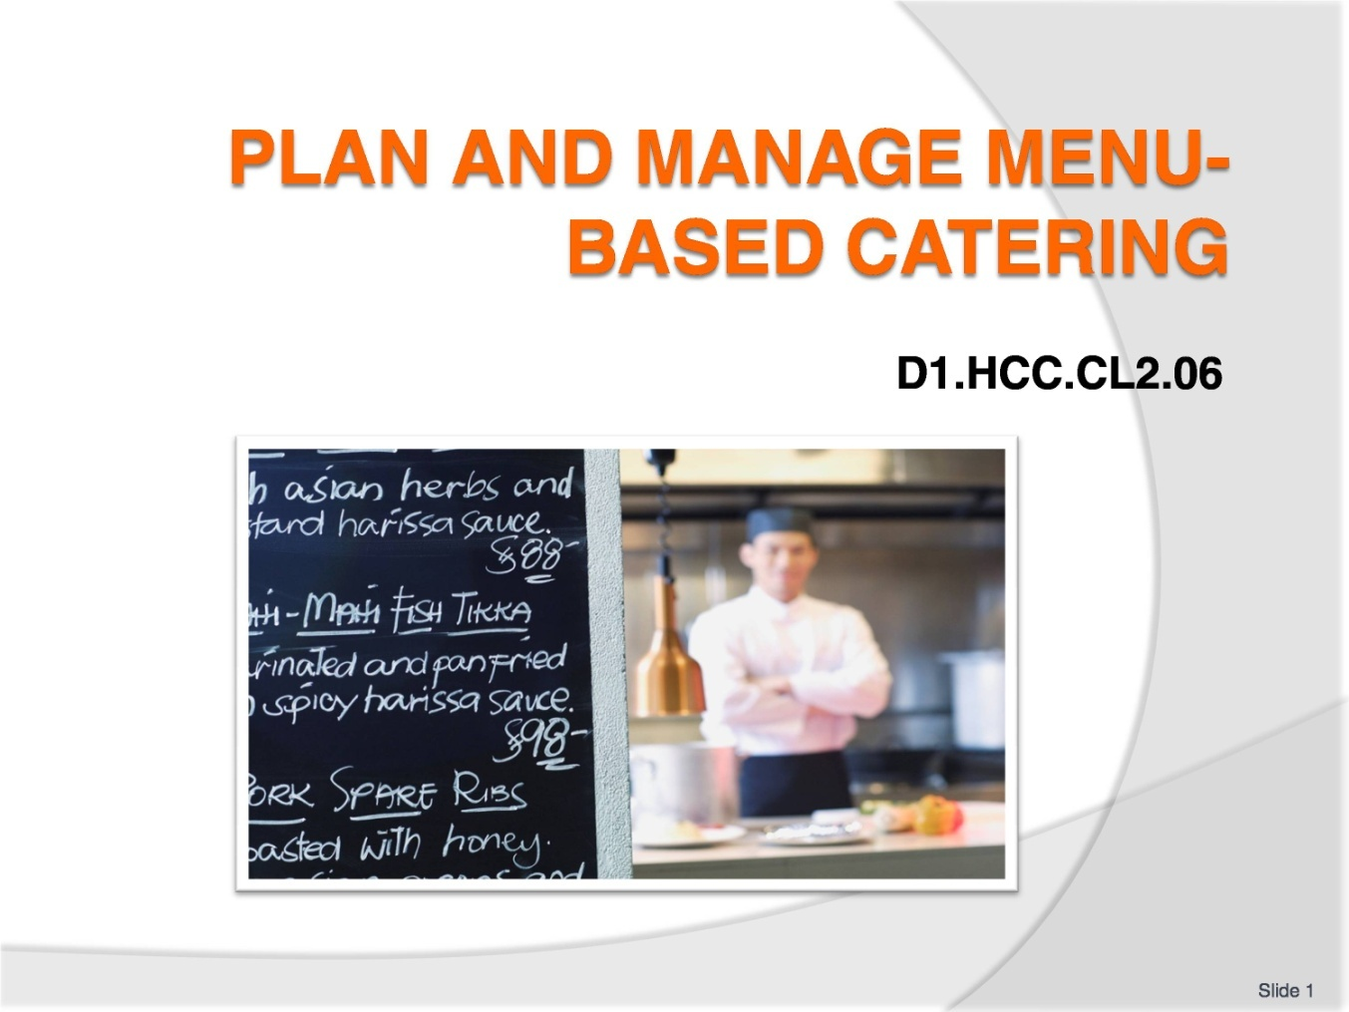
Slide No | Trainer Notes
 | Trainer welcomes students to the class and informs them they are learning how to plan and manage menu based catering.

Slide
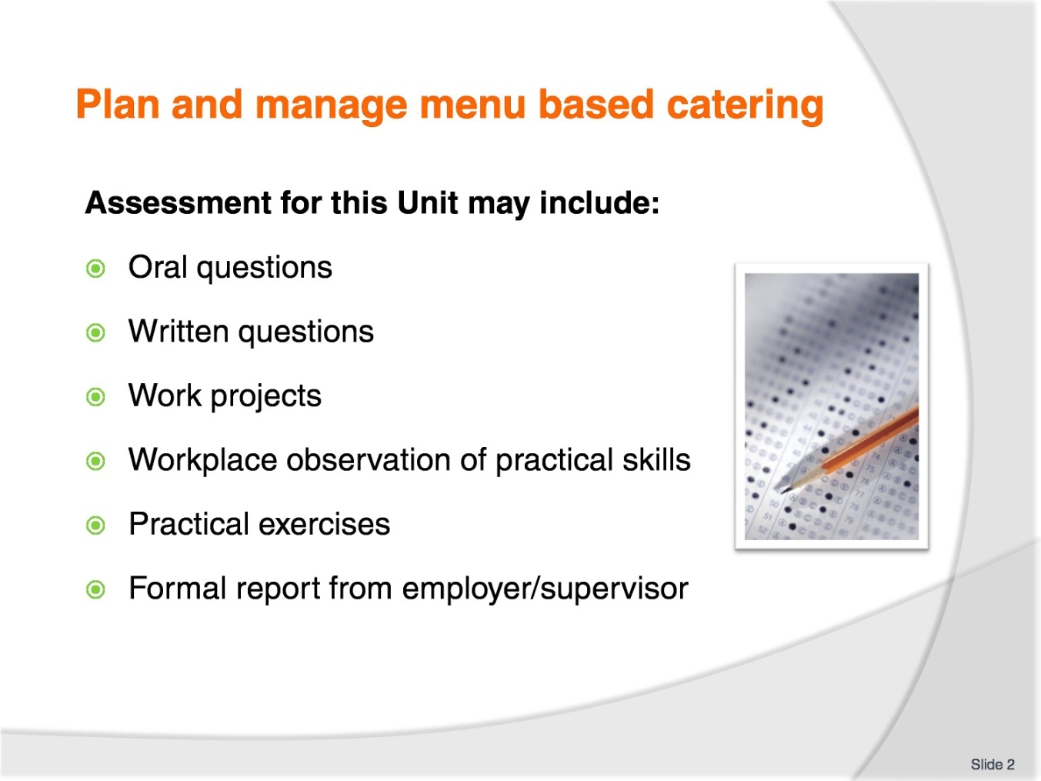
Slide No | Trainer Notes
Trainer to Advise:
Trainer advises students that assessment for this Unit may take several forms all of which are aimed at verifying they have achieved competency for the Unit as required.
Trainer indicates to students the methods of assessment that will be applied to them for this Unit.

Slide
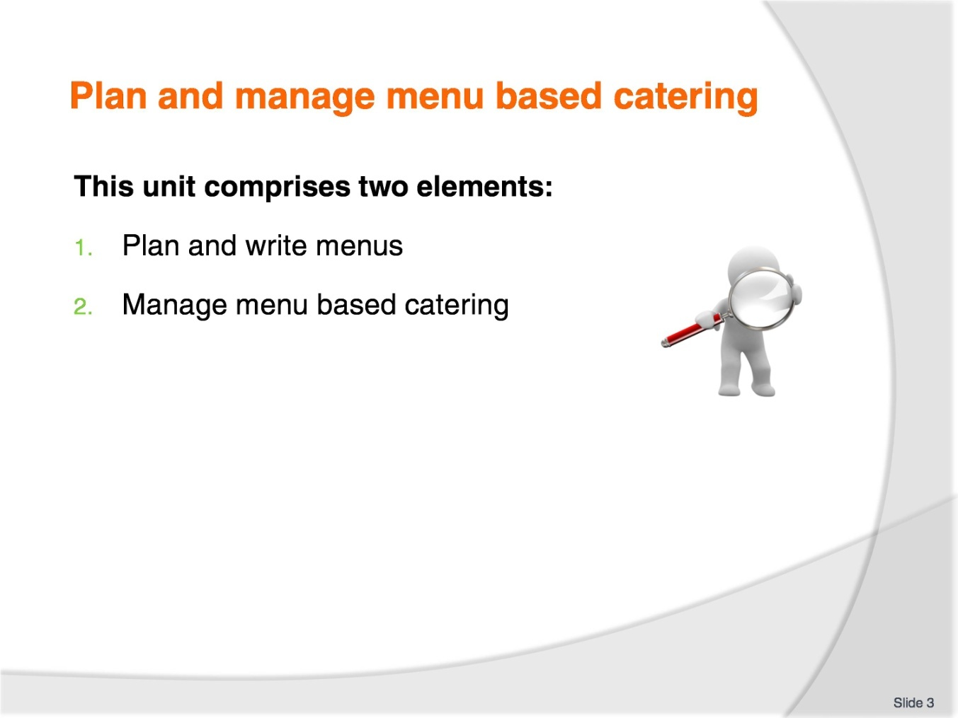
Slide No | Trainer Notes
Trainer advises students this Unit comprises two elements, as listed on the slide explaining:
Each Element comprises a number of Performance Criteria which will be identified throughout the class and explained in detail
Students can obtain more detail from their Trainee Manual
The course presents advice and information but where their workplace requirements differ to what is presented, the workplace practices and standards must be observed.

Slide
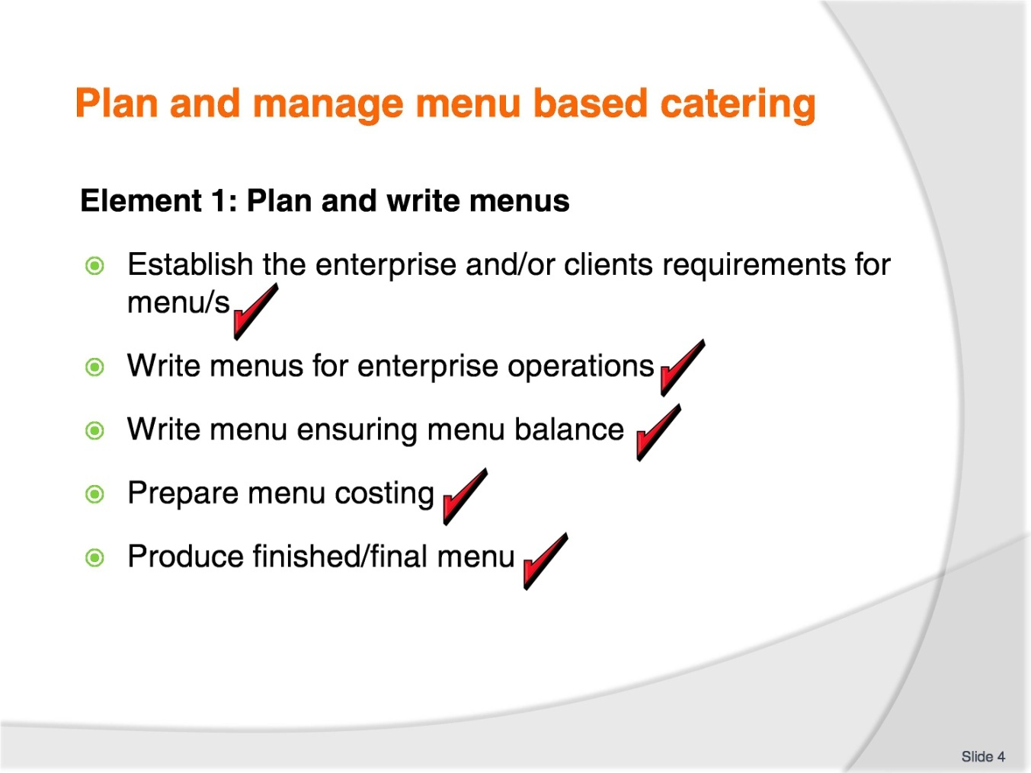
Slide No | Trainer Notes
Trainer to advise:
Trainer to relate performance criteria to element 1.
Performance criteria is the process by which the students training match the learning element. The element is the skill.
To assess competency in the skill; the performance criteria is used to outline activities that can be used to assess competency.
The trainer should relate how the performance criteria is related to the element.
To be able to plan and manage menu based catering the students must be able to plan and write menus.
The student should be able to:
Establish the enterprise and/or clients requirements for menu/s
Write menus for enterprise operations
Write menu ensuring menu balance
Prepare menu costing
Produce finished/final menu.

Slide
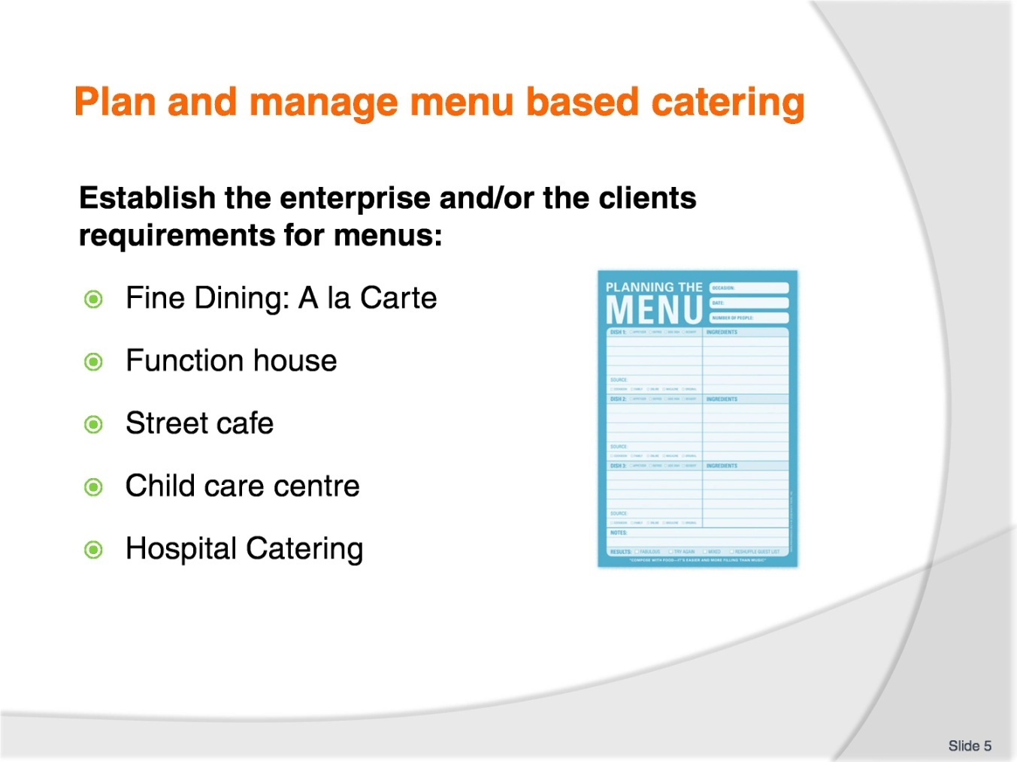
Slide No | Trainer Notes
Trainer to advise:
What is the type of catering supplied and variety of menu required for each?
Café: All day Menu; Breakfast; Lunch; Dinner; Morning Tea; Afternoon Tea; High tea
Function Menus: Weddings; Birthday Celebrations; Business Functions; Football Club; Ladies Card playing club
Luxury Hotel: Fine Dining Restaurant; Café Menu; Function Menus; Poolside Kiosk Menu; Bar Menu in Tapas Bar.
When the type of catering venue has been established then the menu or menus need to be established that will reflect the values of the establishment.
A luxury 5 star venue will have different values to a street café. This does not demean the quality served by the street café it just means that plastic cutlery is used and people sit on older chairs and tables than they might get when they go to a 5 star establishment.
Customers do not expect to receive the same level of service when purchasing from a street café because they know they will not paying the same price.

Slide
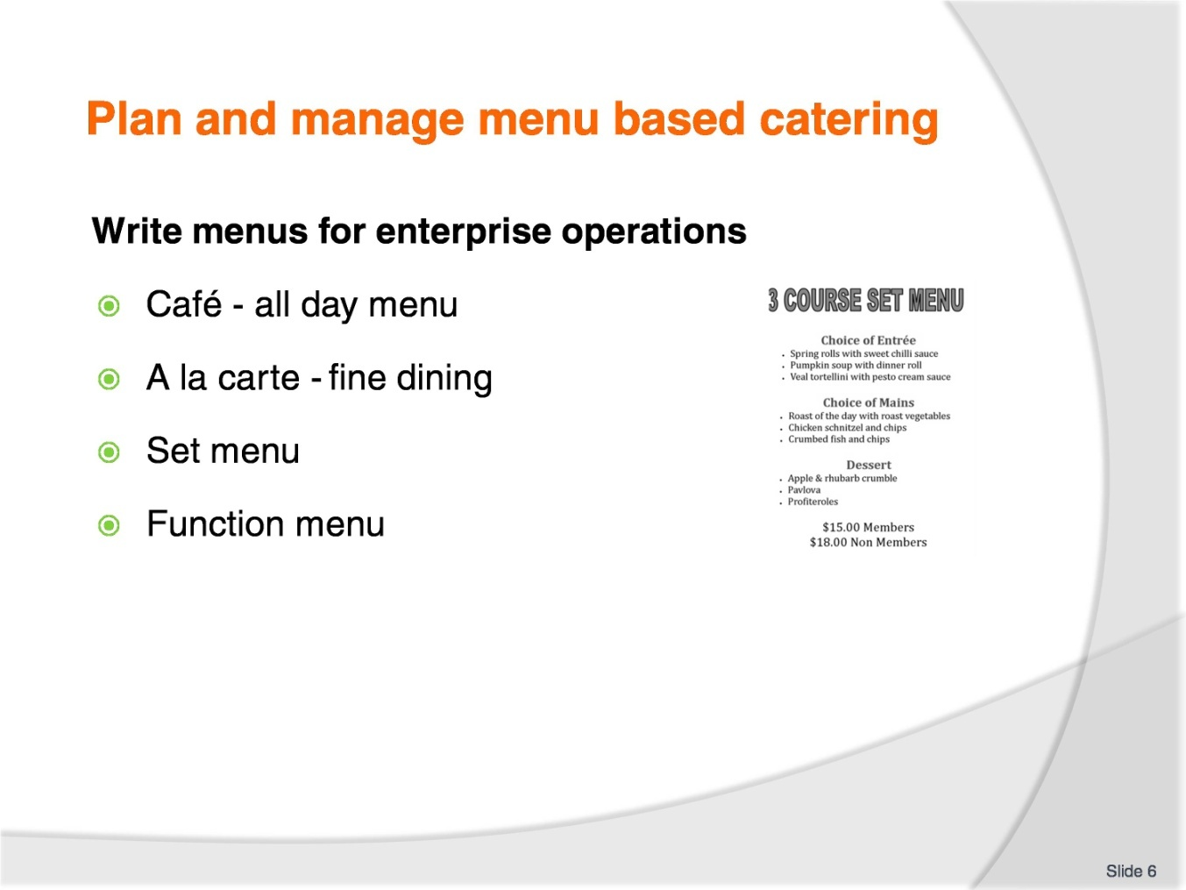
Slide No | Trainer Notes
Trainer to advise:
Cafes will normally have the same menu everyday and never change
Some will offer specials on a daily basis.
Menus for cafes will have light meals at the start then several larger meals to fulfil needs for all potential customers
Menu items needs to be quick to prepare and serve as staffing levels in café’s will be less than fine dining restaurants.
A la carte menus will start with entrée’s followed by main courses then desserts.
Some special cuisines like Italian might have a ‘pasta’ section that is served between entrée and mains.
Other names for entrée may be starters; these might be smaller in size
Set Menus:
Set menus will be used in many places. All the term means is that the number of persons that the menu will serve is known before the function starts
The customer chooses from a menu where there may be 8 entrees, 8 main courses, 6 desserts, cheese course, coffee and tea selection, options for friandises
The customers only gets to choose 2 from each section and the customers may change when the food is served at the table.
Function menu:
100 people for the service
50 of each dish is required maybe 10% more to allow for breakages and spillages during service.

Slide
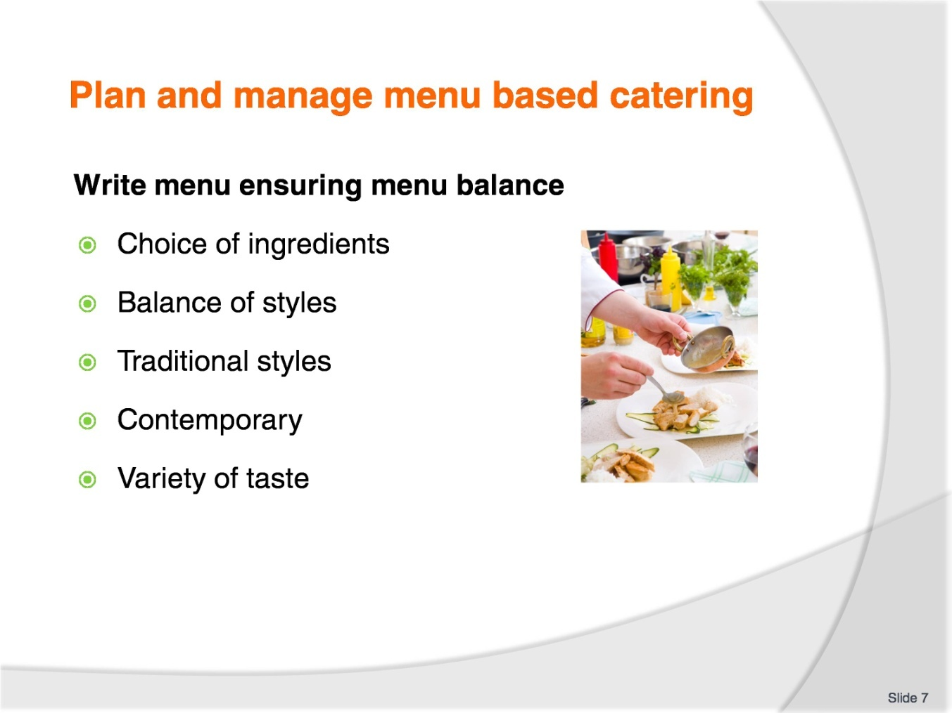
Slide No | Trainer Notes
Trainer to advise:
Menu writing is an skill that requires thought and knowledge of ingredient availability and customers requirement.
The average restaurant or café will be quite predictable.
Occasionally one get a menu that is different and the chef is testing new flavour combinations.
Writing the menu
What are the market requirements. The ‘market’ is a term used to describe the potential customers.
There will be a blend of meat, fish and poultry dishes. There should be some vegetarian as well.
Cold served dishes as well as hot served dishes.
Small serves as well as larger more complete meals.
Desserts may also be offered, but these maybe just be something sweet like cake or pastries.
Is it formal dining or casual? Is the menu traditional or contemporary? Contemporary being a modern twist to a traditional menu item.

Slide
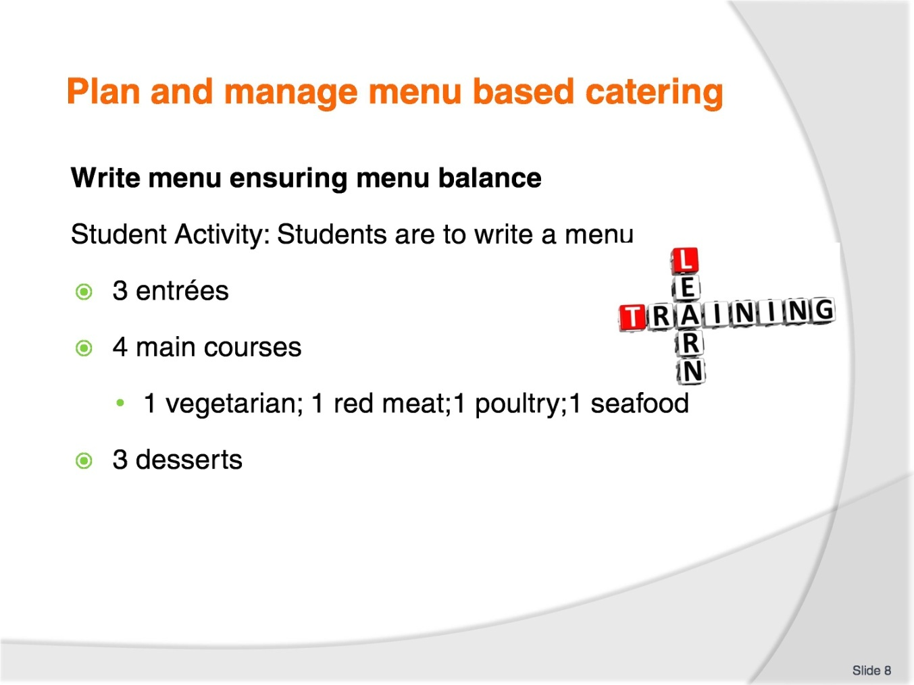
Slide No | Trainer Notes
Trainer to advise:
Menu writing is an skill that requires thought and knowledge of ingredient availability and customers requirement.
The average restaurant or café will be quite predictable.
Entrees may be hot or cold.
Most of main courses will he served hot.
Students may work in pairs or by themselves.

Slide
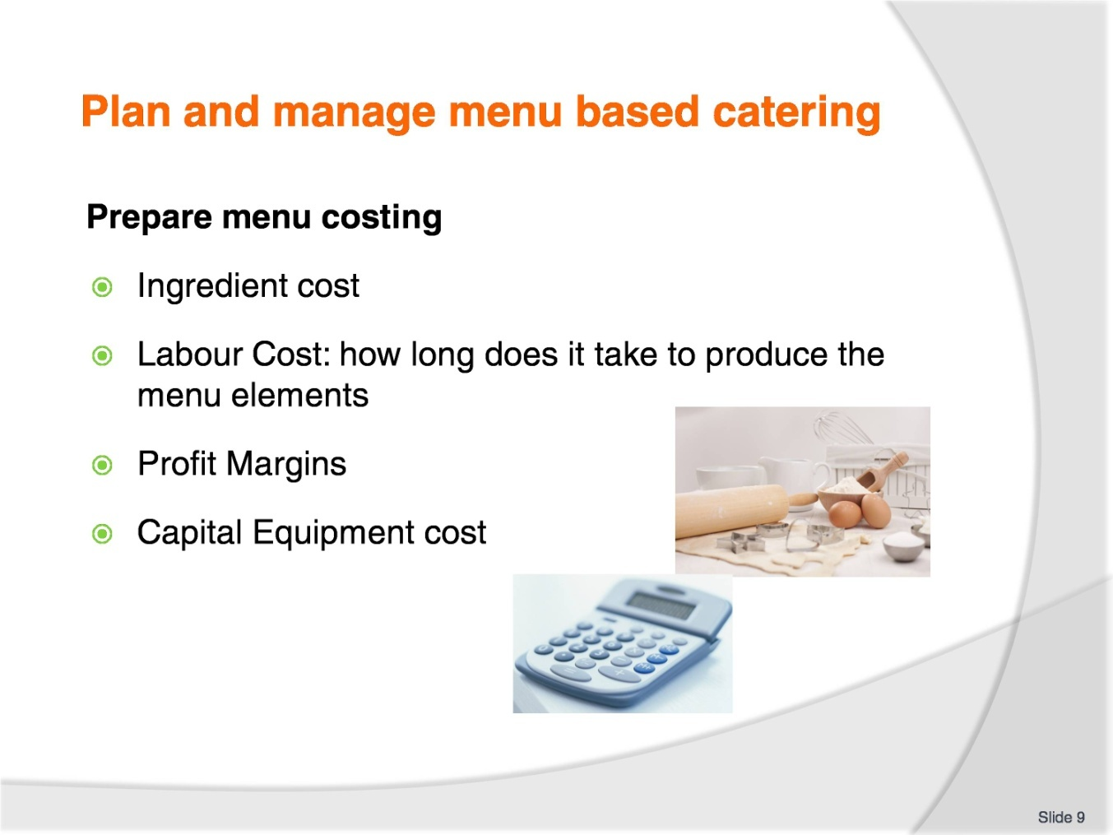
Slide No | Trainer Notes
Trainer to advise:
When preparing menu costing all things need to be considered:
Initially it is the ingredients for a dish
The time taken to produce a dish
Number of elements required
Complexities of producing each element
How long does it take to produce the dish can be effected by the level of equipment used?
When all cost is identified then you have a true cost of production.

Slide
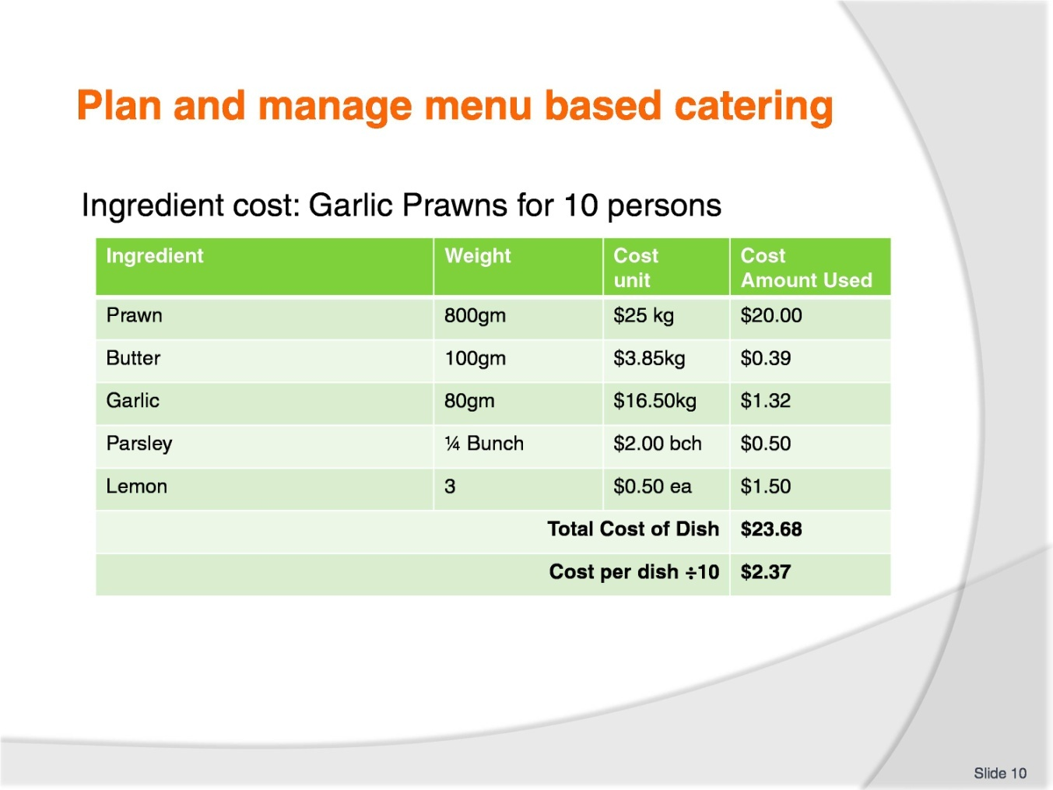
Slide No | Trainer Notes
Trainer to advise:
Several ways to cost.
Basic costing is to decide
- What is in the dish? Recipe
- How much will make a serving? Chef and Enterprise manager to decide
- Will base recipe serve 10 people?
- 10 is used because it is easier to multiply base figure: 25 becomes 2.5 times the recipe
- Develop recipe for 10 people
- Price ingredients against cost of purchasing. Most things are priced by the kilo.
$10.00 per kilo: 385grams is 10 multiply by .385; this equals $3.85.
$13.45 per kilo: 385grams is 13.35 multiply by .385; this equal $5.18.
After ingredients cost then labour cost needs to be identified but this is priced in the cost of manufacturing.
It should be noted that some dishes take longer to prepare than others.
This is allowed for in averaging.

Slide
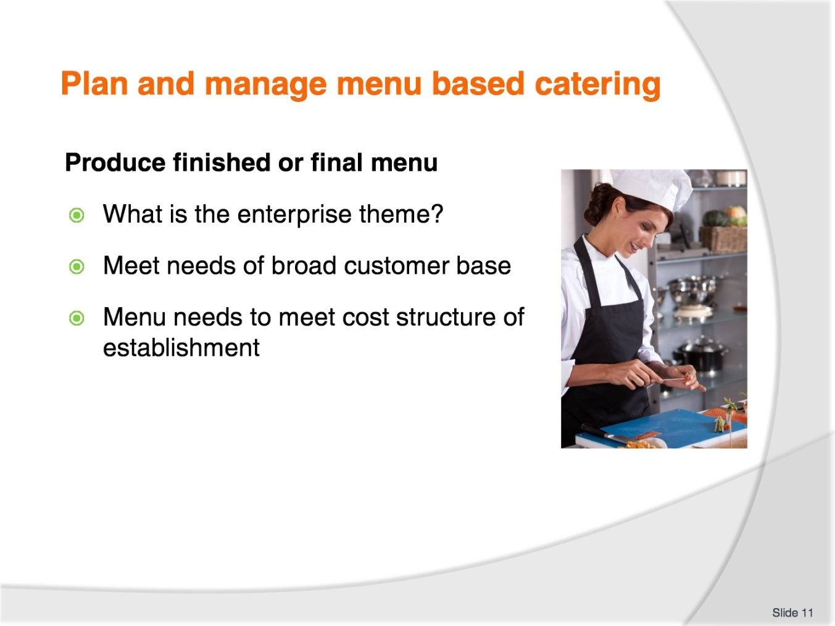
Slide No | Trainer Notes
Trainer to advise:
Student will need to write a contemporary menu with entrée, main course and desserts items.
Working under direction of their Trainer the student will have to construct a menu to fit the needs of the enterprise in which they are working.
Develop a theme
Customer base are meat eaters, vegetarians, seafood eaters, rice eaters
People with preference for fast service and budget prices
People with the money to spend and an expectation of quality
What is your menu going to reflect?

Slide
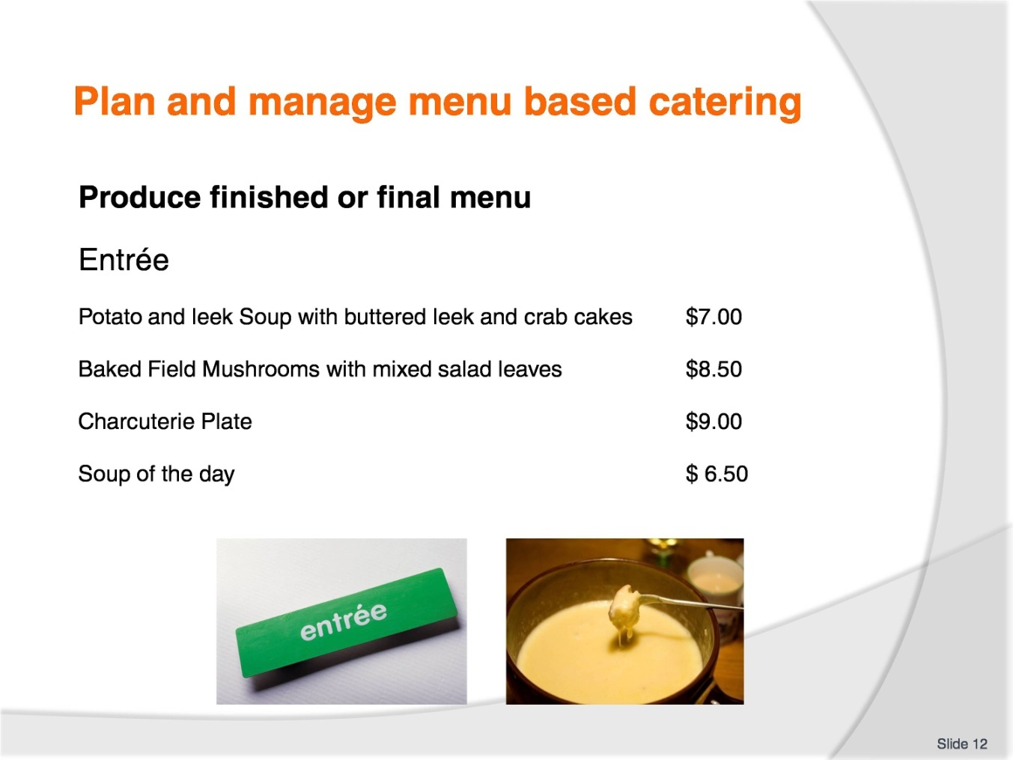
Slide No | Trainer Notes
Trainer to advise:
Student will need to write a contemporary menu with entrée, main course and desserts items.
Working under direction of their Trainer the student will have to construct a menu to fit the needs of the enterprise in which they are working.
Many restaurants have menus online so students can access this rich resource for inspiration.
Remember:
What sells well in one area may not sell well in another.
Entrees:
Light, not too heavy
Allow for all types of diners.

Slide
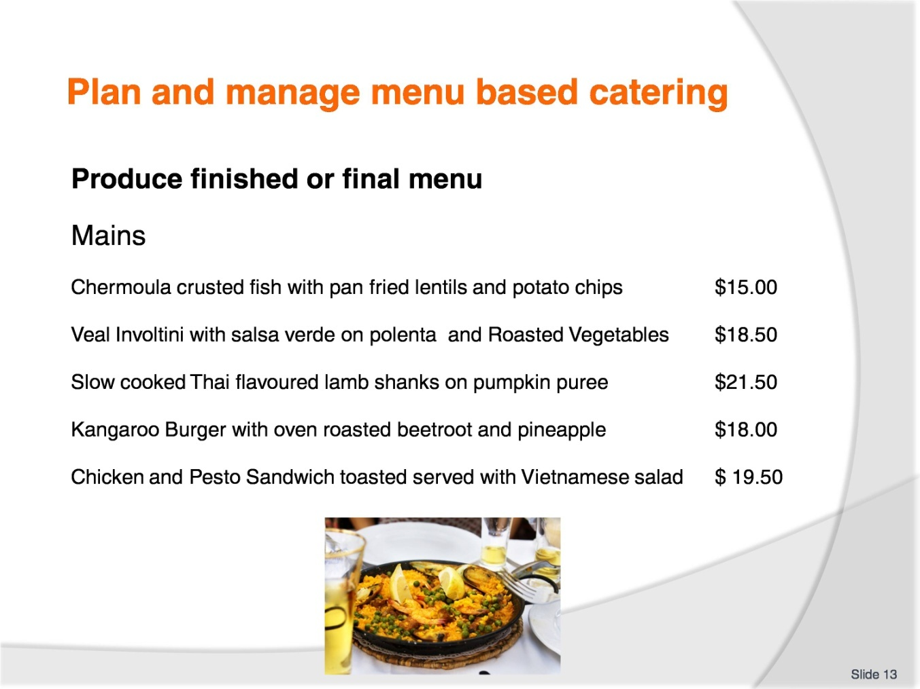
Slide No | Trainer Notes
Trainer to advise:
Student will need to write a contemporary menu with entrée, main course and desserts items.
Working under direction of their Trainer the student will have to construct a menu to fit the needs of the enterprise in which they are working.
Mains:
Most customers will have a main course
Not all will have an entrée
Not all will have a dessert
This is where 80% of your extra sales will be from.

Slide
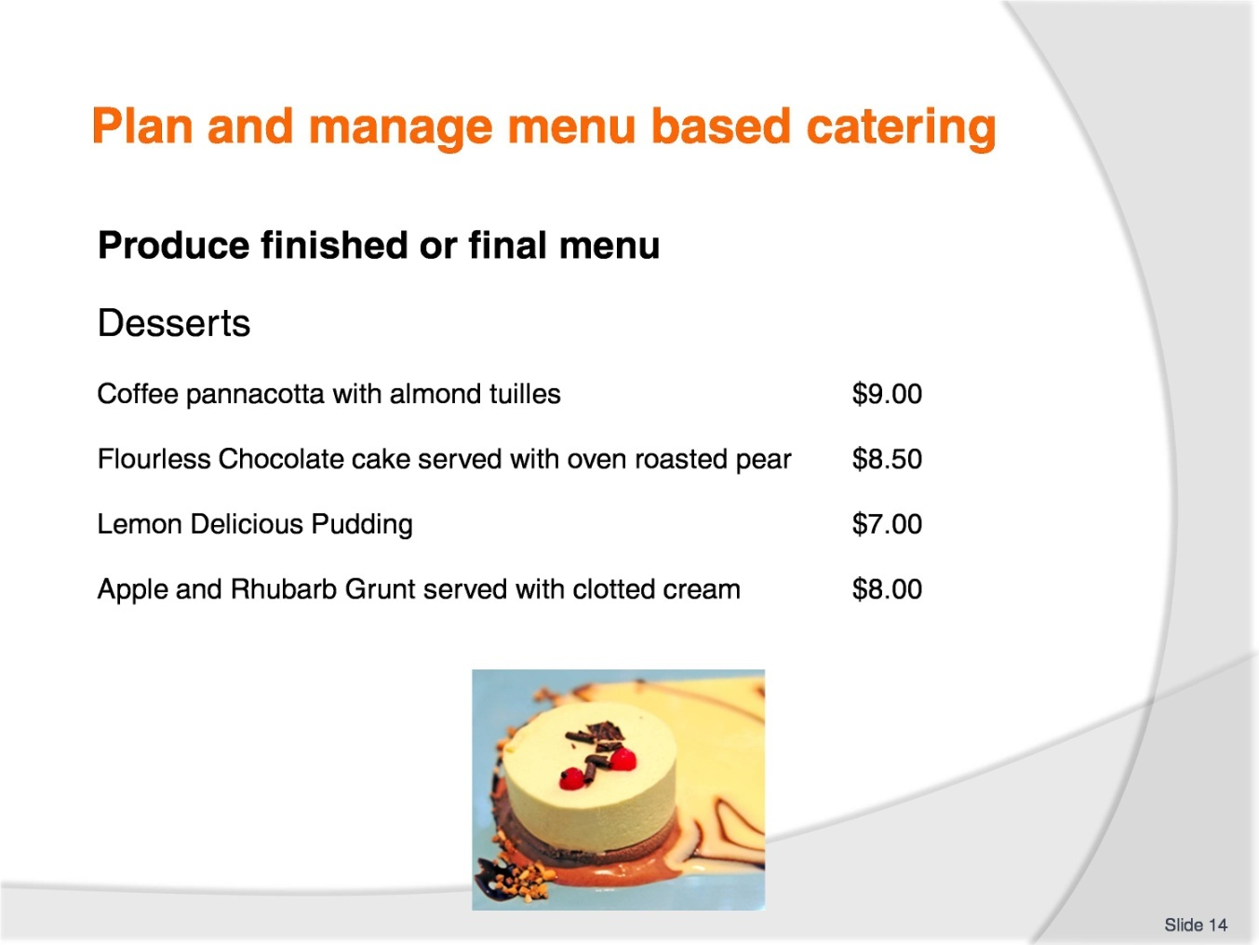
Slide No | Trainer Notes
Trainer to advise:
Student will need to write a contemporary menu with entrée, main course and desserts items.
Working under direction of their Trainer the student will have to construct a menu to fit the needs of the enterprise in which they are working.
Not all are going to have desserts.
Selling a dessert as well as entrée and main course will be the most profitable dish.
What is this so?
When customers sit at a table in a restaurant then they have used the tablecloth and has to be changed when they leave.
The more that is served to them the lesser the cost of the table per course.
If they purchase 3 courses then more money has been made from that one sitting than if they have just an entrée then leave.

Slide
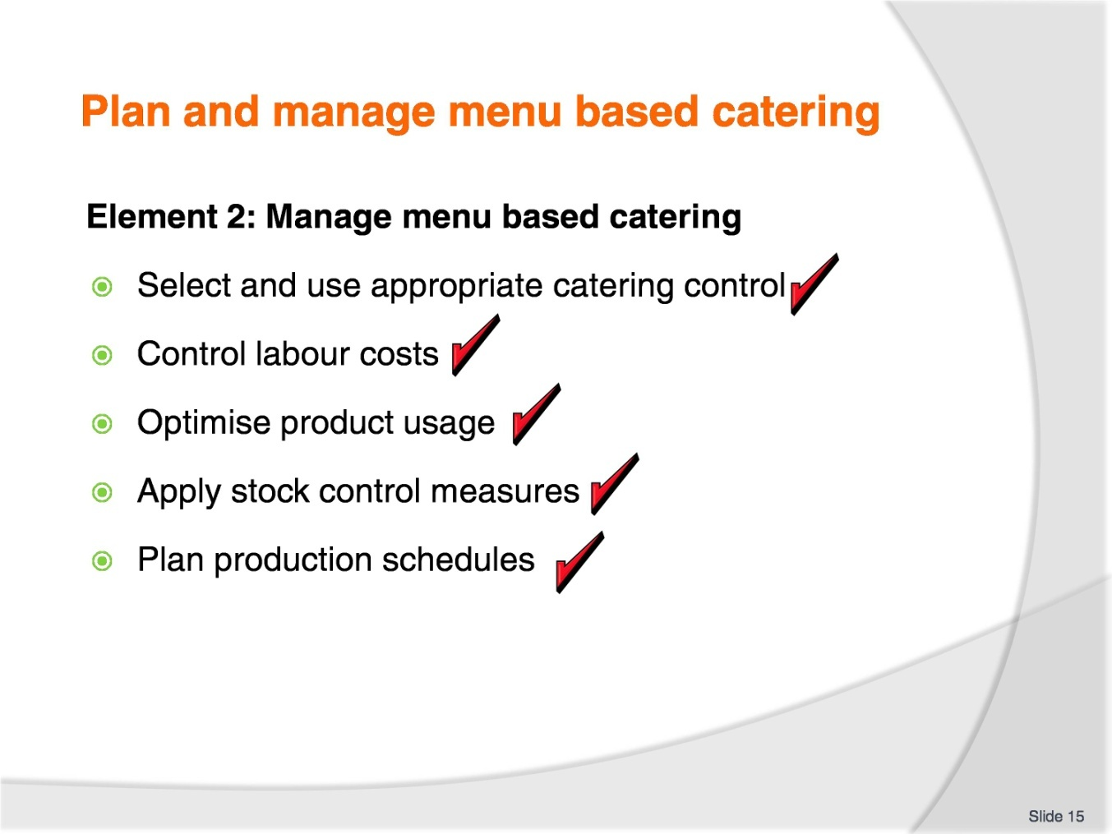
Slide No | Trainer Notes
Trainer to advise:
Trainer to relate performance criteria to element 2.
Performance criteria is the process by which the students training match the learning element. The element is the skill.
To assess competency in the skill; the performance criteria is used to outline activities that can be used to assess competency.
The trainer should relate how the performance criteria is related to the element.
To be able to plan and manage menu based catering the students must be able to manage menu based catering.
The student should be able to:
Select and use appropriate catering control
Control labour costs
Optimise product usage
Apply stock control measures
Plan production schedules.

Slide
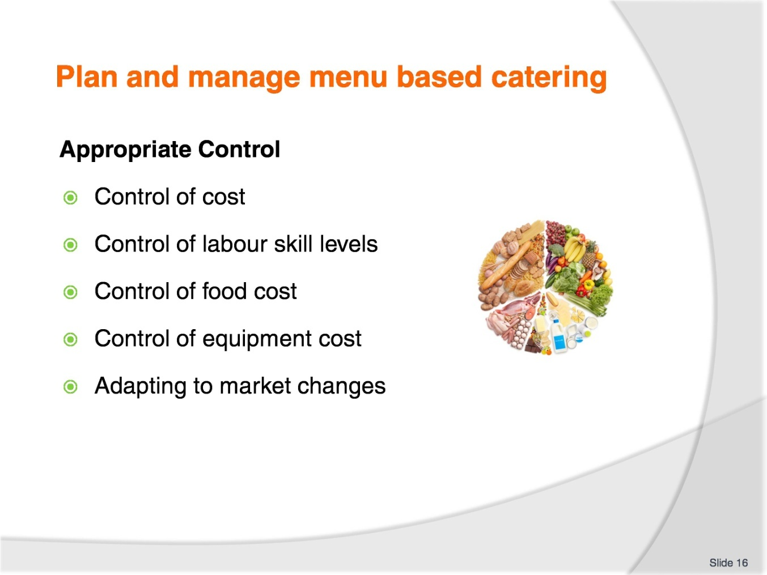
Slide No | Trainer Notes
Trainer to advise:
Control is about Knowledge.
What are the costs?
All costs need to be understood if the correct charges are to be applied
A menu dish may be popular but is the return to the enterprise sufficient to cover the true cost of manufacturing.
Where can they be controlled?
Accurate control of menu production is required
Are staff all working to same formula? Are some staff using more to produce same quantities
Serving sizes are all the same: These can be averaged but average serving sizes.
How can they be controlled?
Working to standard recipes
Training of staff
Auditing of processes
Mentoring of staff development
Utilising leftover trimmings in other dishes.

Slide
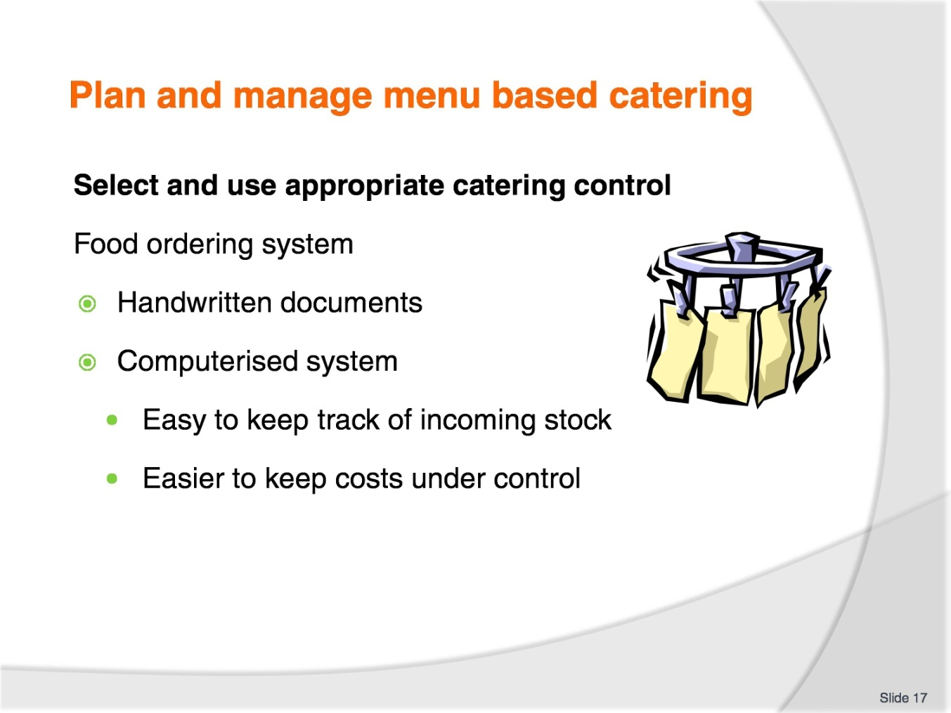
Slide No | Trainer Notes
Trainer to advise:
System of food ordering and purchasing agreement for specific time periods
Modern methods of computerised ordering makes ordering much simpler
Smaller premises may have to order by handwritten documents so it is important to keep records of what is ordered
Ledger books with pre ruled lines are fine examples that can be adapted for hand written document.
Students are encouraged to adopt modern methods of computerised ordering.

Slide
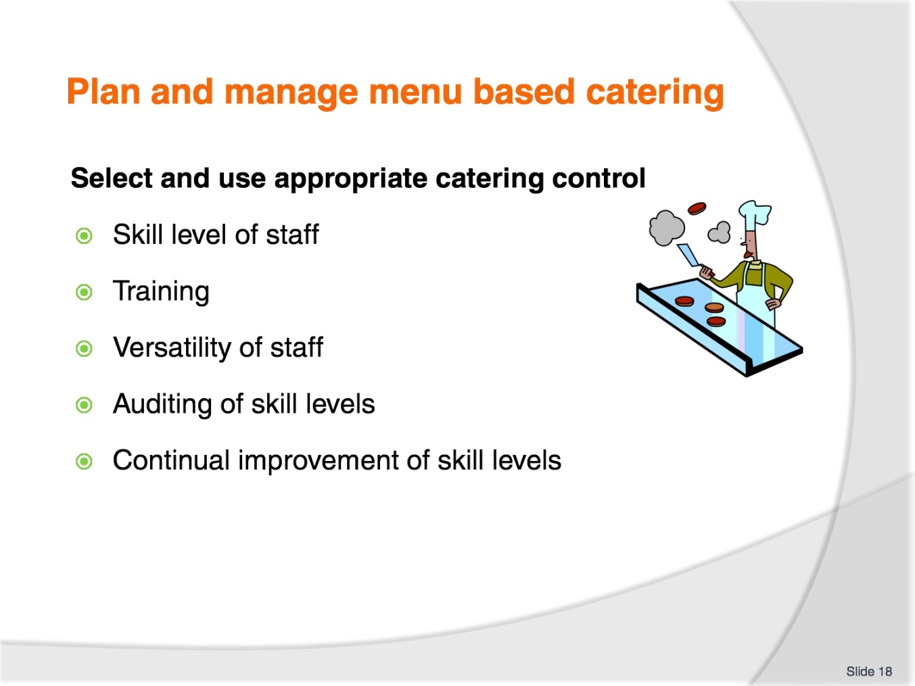
Slide No | Trainer Notes
Trainer to advise:
Skill level of the staff will be paramount when deciding on the theme of the enterprise:
Are they prepared to cook food different to what they know?
Do they understand the different techniques required?
Conduct an audit of staff skill levels; do not assume they know
What training has been done by the enterprise?
Do all staff know what to do in event of fire in kitchen?
Where are extinguishers?
What type of extinguishers are available; foam, powder?
Where is gas shut off valve?
Do staff know how to stop bleeding resulting from cuts with sharp objects?
Can they all apply bandages for simple first aid until medical specialists can be summoned?
Skills is not always about the cooking.
Cooking skills mean versatility. The more they can do the more flexible they are to the kitchen work.
Training of staff is ongoing and continual.

Slide
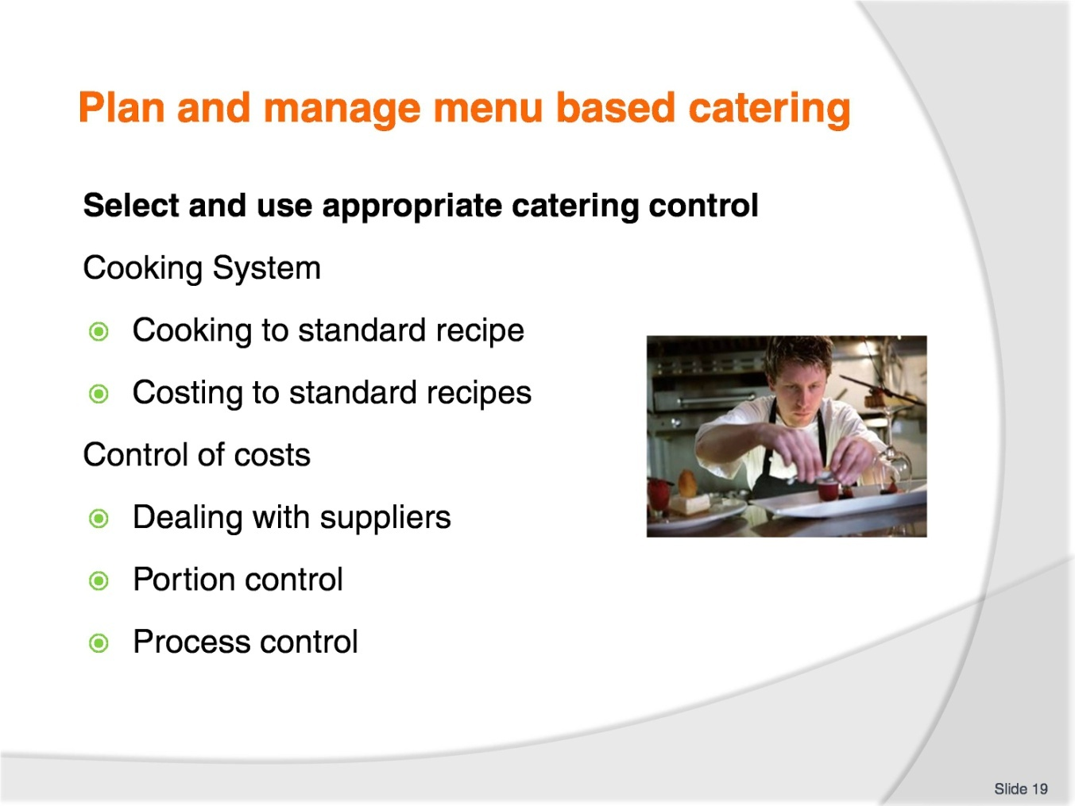
Slide No | Trainer Notes
Trainer to advise:
All staff need to be cooking product the same way
Working to same recipe and method of production.

Slide
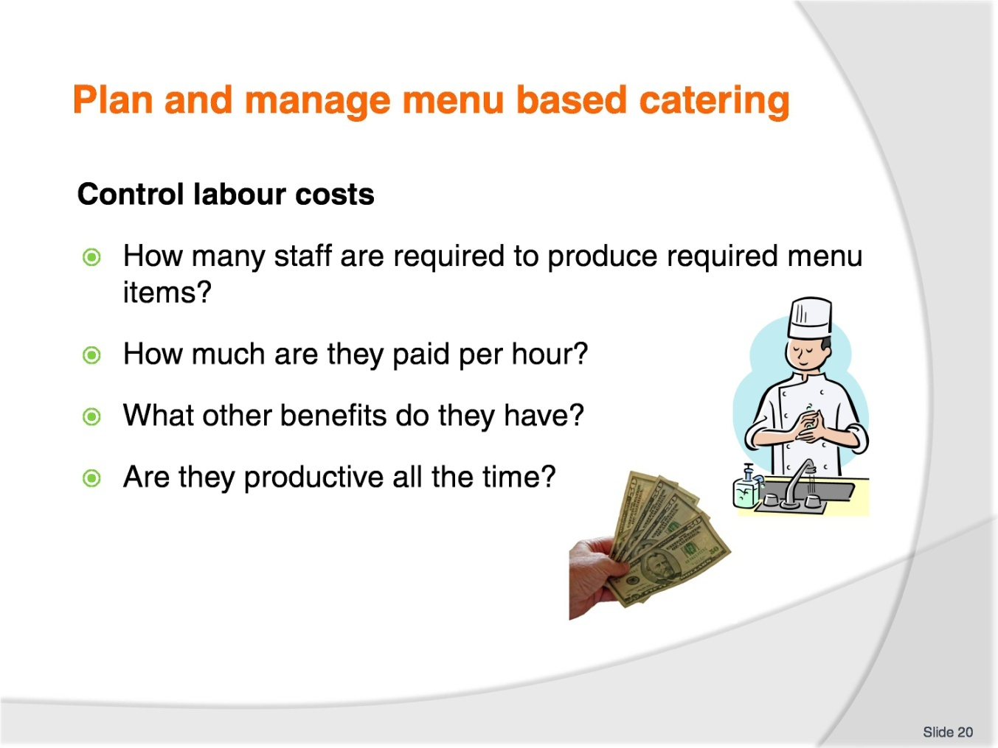
Slide No | Trainer Notes
Trainer to advise:
Labour is a big cost in any kitchen. It is not just the cost of how much per hour staff are paid but also the on cost.
Are they supplied lunch, tea and coffee facilities, laundry allowances, medical insurance and benefits?
These may not all be required in your kitchen but all needs to be looked at if you are in charge of paying staff all correct allowances.
Having staff that are not needed is an expensive error.
Not having enough staff can be expensive if customers walk out because they have not been served quick enough.

Slide
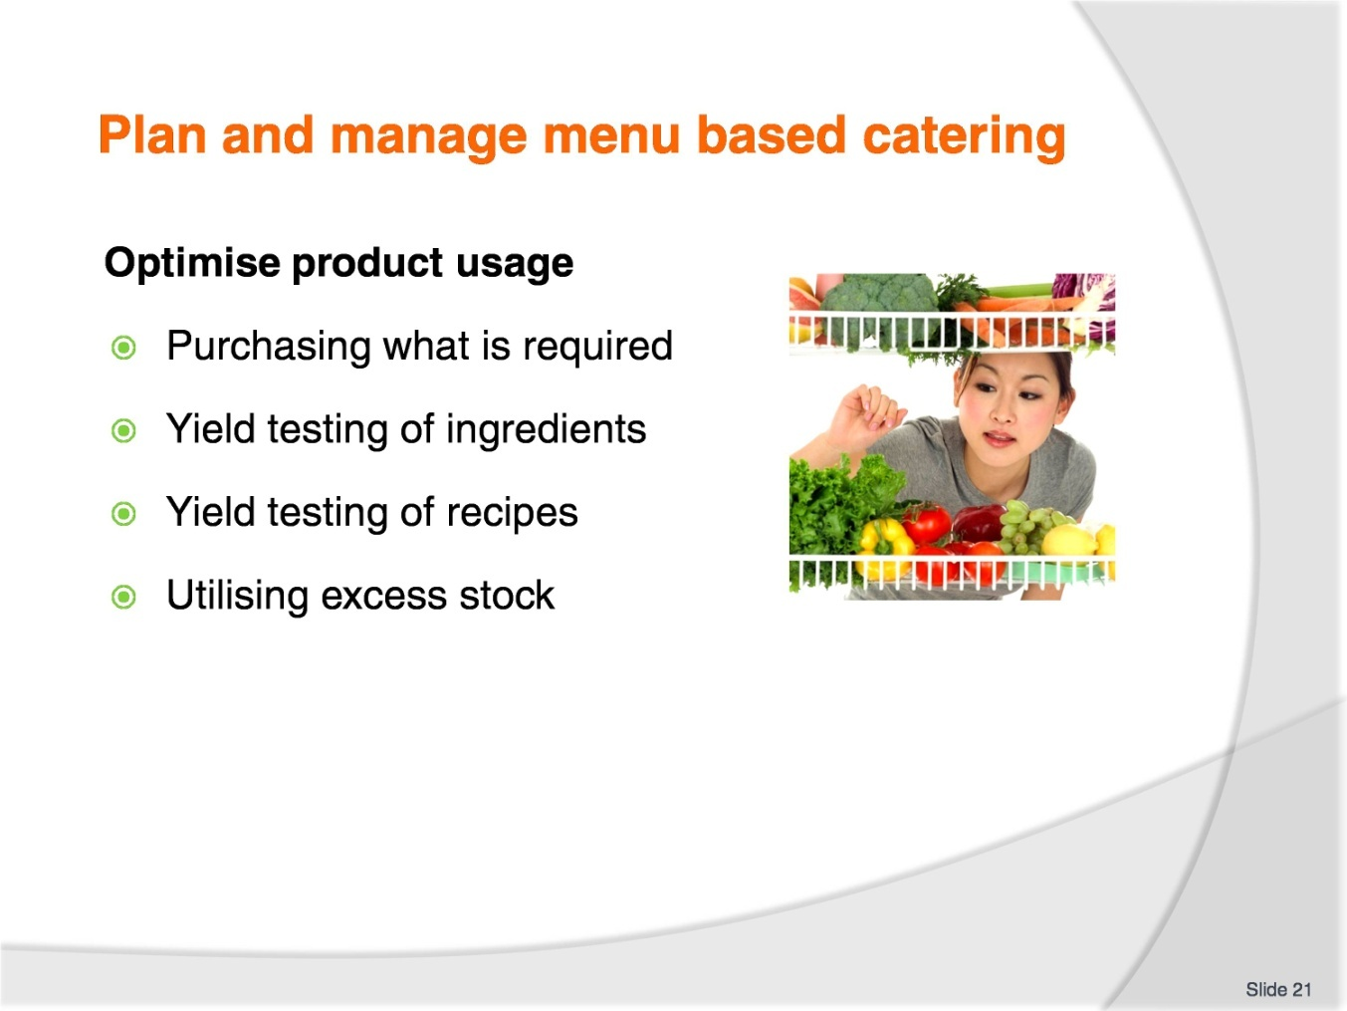
Slide No | Trainer Notes
Trainer to advise:
Purchasing for a la carte is very difficult as exact numbers that may be required is the great unknown.
Averaging of purchasing and record keeping are the best ways of controlling build-up of excess stock.
When a kilo of onions are peeled; how much usable flesh is available?
When a kilo of peeled onions are sliced; how much sliced onion is achieved?
When a kilo of onions are diced; how much usable product is achieved?
When the lamb casserole is finally cooked:
- How many serves are actually available for service?
- What is the average size of the serving?
Nothing is ever going to be set; averaging will always have to be used.
Some things can be controlled more than others.
There must be control so it is important to understand where they can be controlled and when is the best time to put these controls in place.

Slide
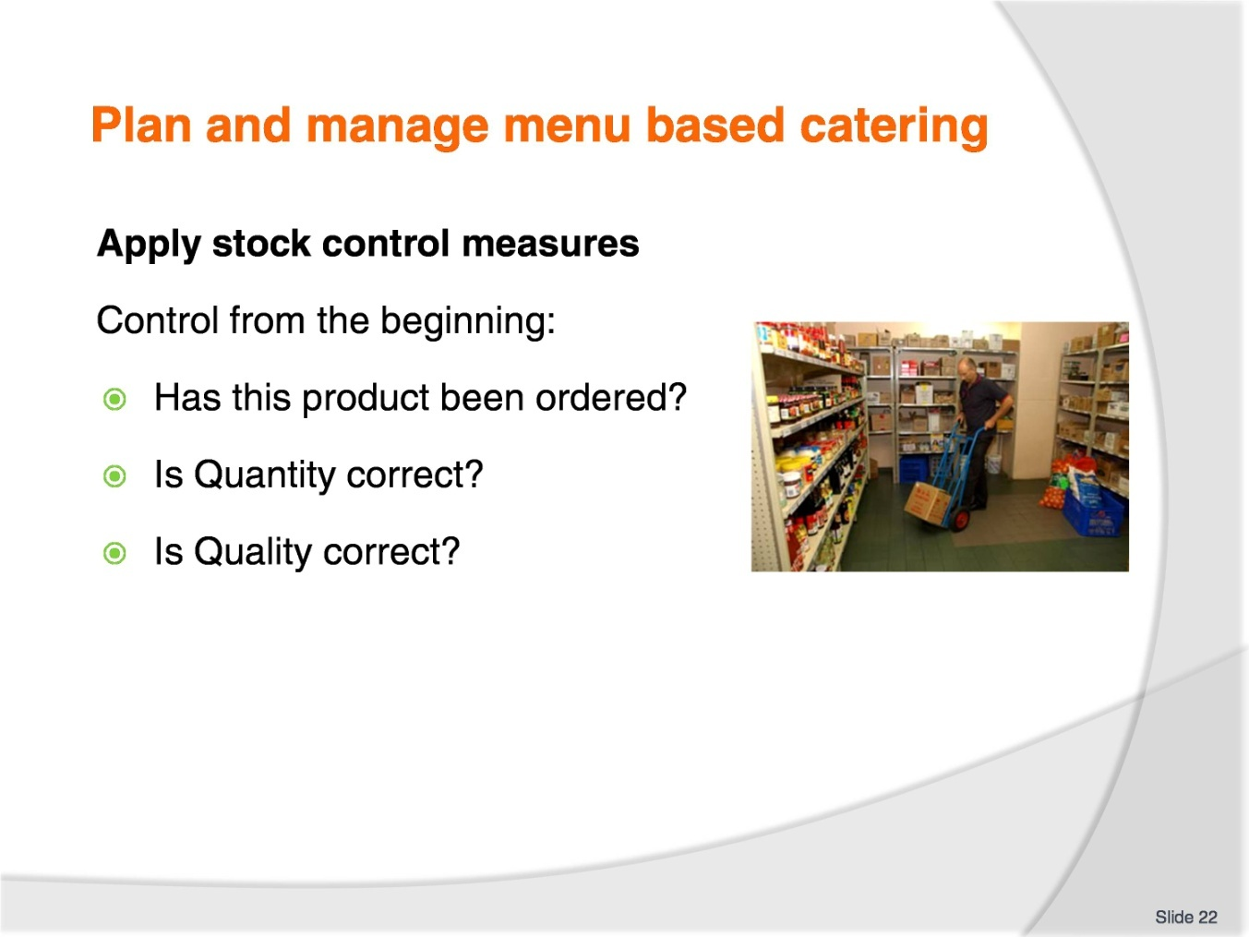
Slide No | Trainer Notes
Trainer to advise:
When receiving the stock that has been ordered it is important to check that it is what was ordered.
If this is not started here then control has been lost and people will be trying to present a menu items with ingredients that may not be of the same quality standard previously used.

Slide
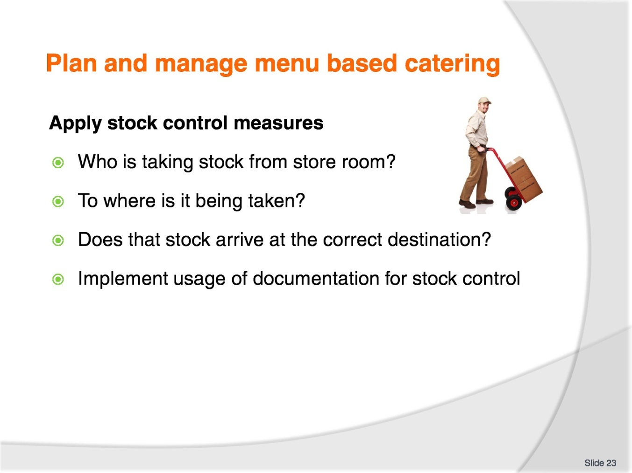
Slide No | Trainer Notes
Trainer to advise:
Larger establishments will have more control measures in place than smaller premises.
Larger establishments will have a greater risk of theft and pilfering than smaller places.
Where larger quantities are stored there will be more temptation to take just one and not think it will be missed than in smaller establishments.
Stock control measure will be in place in larger establishments that have multiple kitchens.
Internal dockets of stock transfers with delivery dockets and stock being signed and accepted.

Slide
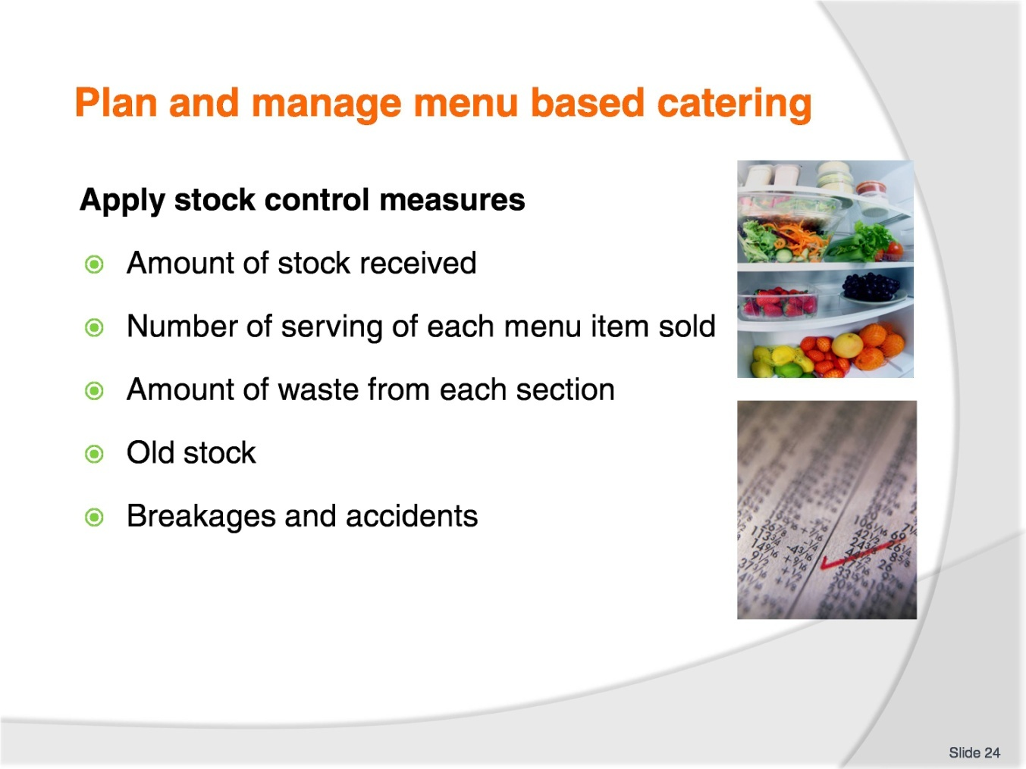
Slide No | Trainer Notes
Trainer to advise:
As stock is dispersed around the establishment there needs to be a check on stock usage.
In a perfect world it would all match.
Food for 50 serves in: 50 serves out: 50 sales; maximum profit.
Where people are involved there will be accidents.
Where people are involved in portioning there will be less correct serves.
20 ml of sauce per person from 1 litter of sauce= 50 serves.
Actual number of serves may be as low as 40, average 45 serves would be considered acceptable.
Allow for contingencies but what is acceptable?
Good management of ordering more than what is required always to allow for extras allows for possibility of excess stock building up.
Small satellite kitchens needs to be cleaned out of all excess stock and sent to area for stock to be used.
Normally staff meals section.
Breakages and accidents will happen.
Sometimes human failings, sometime mechanical failings.
Slide
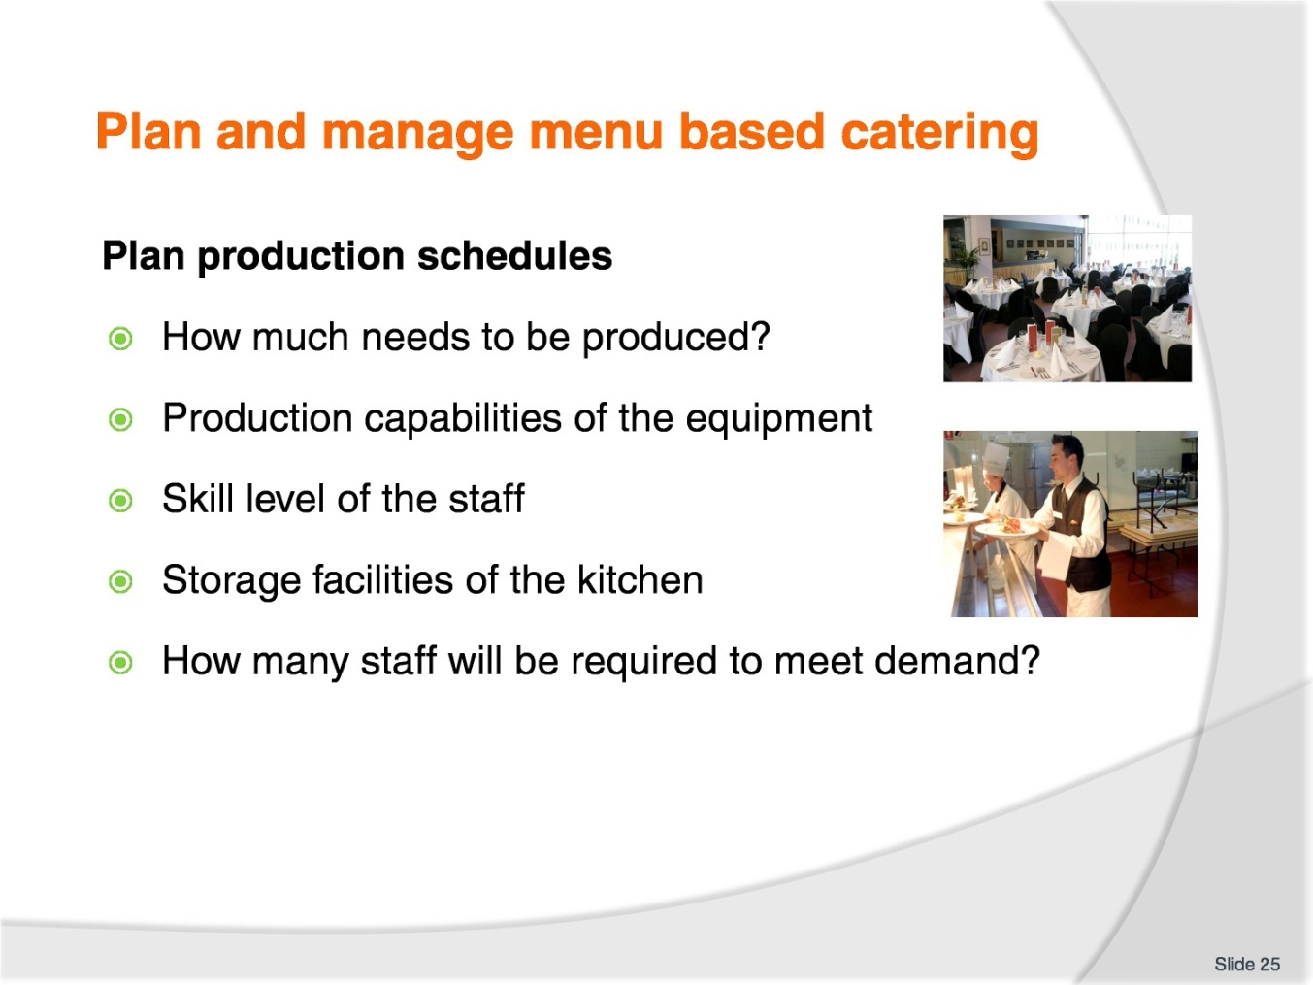
Slide No | Trainer Notes
Trainer to advise:
Production schedules are based around how food needs to be produced to match expected number of sales.
Food production needs time to be allocated depending on the type of food being produced and the processing required to produce said food.
Acquisition of the required stock
Preparation of each ingredient; time required for each step in the process
Special equipment that may be required.
Planning production schedules is complex and allowances must be made for when staff do not turn up to work at required time.

Recommended training equipment
Calculator
Computer
Overhead projector
Recipe sheets
Stock take sheets
Worksheets
Pen
Paper

Instructions for Trainers for using
PowerPoint – Presenter View
Connect your laptop or computer to your projector equipment as per manufacturers’ instructions.
In PowerPoint, on the Slide Show menu, click Set Up Show.
Under Multiple monitors, select the Show Presenter View check box.
In the Display slide show on list, click the monitor you want the slide show presentation to appear on.
Source: http://office.microsoft.com
Note:
In Presenter View:
You see your notes and have full control of the presentation
Your trainees only see the slide projected on to the screen
More Information
You can obtain more information on how to use PowerPoint from the Microsoft Online Help Centre, available at: http://office.microsoft.com/training/training.aspx?AssetID=RC011298761033
Note Regarding Currency of URLs
Please note that where references have been made to URLs in these training resources trainers will need to verify that the resource or document referred to is still current on the internet. Trainers should endeavour, where possible, to source similar alternative examples of material where it is found that either the website or the document in question is no longer available online.

Appendix – ASEAN acronyms
AADCP | ASEAN – Australia Development Cooperation Program.
ACCSTP | ASEAN Common Competency Standards for Tourism Professionals.
AEC | ASEAN Economic Community.
AMS | ASEAN Member States.
ASEAN | Association of Southeast Asian Nations.
ASEC | ASEAN Secretariat.
ATM | ASEAN Tourism Ministers.
ATPMC | ASEAN Tourism Professionals Monitoring Committee.
ATPRS | ASEAN Tourism Professional Registration System.
ATFTMD | ASEAN Task Force on Tourism Manpower Development.
CATC | Common ASEAN Tourism Curriculum.
MRA | Mutual Recognition Arrangement.
MTCO | Mekong Tourism Coordinating office.
NTO | National Tourism Organisation.
NTPB | National Tourism Professional Board.
RQFSRS | Regional Qualifications Framework and Skills Recognition System.
TPCB | Tourism Professional Certification Board.







